Phone: 4845 1129 | Gunning Public School  Grapevine  11.12.12 Term 4 No 10  Web page: www.gunning-p.schools.nsw.edu.au   | 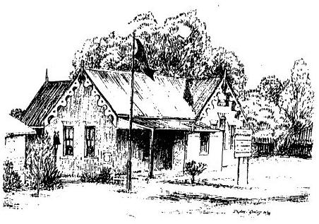  Fax: 4845 1236
“Together we are safe, respectful learners working hard to achieve success”

Monday Tuesday Wednesday Thursday Friday
Week 10  10th-14th Dec |  | Pizza Day | K-3 excursion to Goulburn rail museum | Classroom Helpers Thankyou Afternoon Tea  Tennis | Reports home
Week 11  17th-21st Dec | Presentation Night  6.30pm |  | Last day for students | SDD | SDD |  |  |  | Kindy Start  Tennis

Christmas Hamper Raffle
Donations for the Christmas hamper are still welcome and tickets are still for sale.
We have made up 4 hampers for the lucky winners. Some goodies include leg ham, homemade fruit cake, silver side and pickled pork as well as biscuits, chocolates and plenty more .
Tickets are $2 or 3 for $5.
Drawn this Friday at morning assembly.

K-3 Excursion - Tomorrow
K-3 will be going to visit the Roundhouse (Railway) Museum on Wednesday 12th December for their end of year excursion this year. After visiting the museum they will have their lunch in Belmore Park, Goulburn.

P&C Meeting – this Thursday night
We will be discussing potential changes to the school uniform, if you would like to have your say please join us in the Library at 7pm.

Presentation Evening
Presentation will be held at the Shire Hall on Monday 17th December commencing at 6.30pm.
The children are to wear their Sport uniform or costume to Presentation.

Library Books
No borrowing this Friday. All Library books outstanding are to be returned by Friday 14th December.

2013 Enrolments
We are still taking enrolments for 2013. If you know of anyone who has a child eligible to enrol next year ask them to call into the office to collect an enrolment form or give us a call and we will send the forms out. We are also happy to answer any questions that they may have.

No Hat No Play
With the warmer weather hopefully here to stay, the children will again need a brimmed hat to play in unshaded areas.

Vacation Care Program
Attached is the program for the December/January school vacation. For bookings ring 4845 1710.

Pre-Loved Uniforms
Anyone who has uniforms that are in good order that their child/children have grown out of, it would be greatly appreciated if you could donate them to the school for our clothing pool as we have no smaller uniforms.

SCHOOL UNIFORM

Gold Fleecy Tops $18
Black Polar Fleece Vests $18
Black Polar Fleece Jumpers $33
Jackets $63
Gold & Blue Polo T-shirts $18
School Hats $8
Girls Long-Sleeved Peter Pan Collar Shirts $22
Girls Pinafore $60
(Contact Sue Marshall to make on 4845 1618)
Material for Summer Uniform $8 metre

Email Addresses for Grapevine
If you would prefer to receive your Grapevine by email, please advise the front office of your email address

TERM 4
 | MONDAY | TUESDAY | WEDNESDAY | THURSDAY | FRIDAY
Week 1  8th – 12th Oct | Back to School |  |  | Tennis  P&C Meeting  7pm
Week 2  15th-19th Oct |  |  |  | Tennis  NSW PSSA  Athletics | Bookclub Order  to school
Week 3  22nd-26th Oct | Assembly  2.45pm | BBQ Lunch |  | Tennis | 4/5/6 tree planting at Barbour Park
Week 4  29th Oct-  2nd Nov |  | Musica Viva |  | Tennis
Week 5  5th-10th Nov | Assembly  2.45pm  2/3 item |  |  | Tennis
Week 6  12th-16th Nov |  |  |  | Kindy Start  Tennis | 150 Years Goulburn Policing
Week 7  19th-23rd Nov | Assembly  2.45pm  K/1 and 4/5/6  Bookclub Due |  | Renewable Energy Day | Kindy Start  Tennis
Week 8  26th-30th Nov | Swimming School | Swimming School | Swimming School | Swimming School  Kindy Start  No Tennis | Swimming School
Week 9  3rd-7th Dec | Swimming School  2013 Captain speeches and voting 9:30am | Swimming School | Swimming School  GGs Christmas Party | Swimming School  No Tennis | Swimming School
Week 10  10th-14th Dec |  | Pizza Day | K-3 excursion to Goulburn rail museum | Classroom Helpers Thankyou Afternoon Tea  Tennis | Reports home
Week 11  17th-21st Dec | Presentation Night  6.30pm |  | Last day for students | SDD | SDD

