Gunning Public School

Phone: 4845 1129

Fax: 4845 1236

Web Page:
www.gunning-p.schools.nsw.edu.au
8.12.09 Term 4 No 40

THIS WEEK  8/12 Presentation Night  10/12 Year 6 Fun Day  11/12 Reports home  Year 6 Farewell School Hall 5-7 pm | NEXT WEEK  14/12 Assembly PBS awards  Guitar Group Item  16/12 Last day of school | CANTEEN  11/12 Kylie Hazell  14/12 NO CANTEEN

“Together we are safe, respectful learners working hard to achieve success”

IMPORTANT KNOWN DATES FOR TERM 4 2009

- Mon 30/11 – Fri 11/12: Swim Scheme – Gunning Pool K/1
- Tues 8/12: Presentation Night Shire Hall @ 6:30pm
- Thurs 10/12: Year 6 Fun Day
- Fri 11/12: Reports sent home
- Fri 11/12 Year 6 Farewell and Social @ 5:00-7:00pm
- Mon 14/12: Assembly PBS Recognition @ 2:45pm
- Tues 15/12: End of Year Excursion to Lilac City Cinemas
- Wed 16/12: Last day of school for students
- Thurs 28/1/10: First day of school Years 1-6
- Fri 29/1/10: Kinder Best Start observations
- Mon 1/2/10: Kindergarten start full-time

PRINCIPAL’S MESSAGE

Good news! Our computer system has been upgraded. We were expecting it to be done in Term One next year, but we’ll take it when we can get it! Previously only 10 children could be accessing the internet and saving work at one time without complications. Now it is a much better, faster system.

This is our final newsletter for the year. The Gunning Public School staff thank you for a great year, and wish you all the very best for a happy and safe Christmas. My personal thanks to the school community (staff, students, parents, helpers) for the friendly words, unfailing support and hard work in 2009.

YEAR 6 DINNER
Last week’s Grapevine advertised the wrong date for the Year 6 Farewell Dinner and Social – it should have read Friday 11th December between 5:00 – 7:00pm. Our apologies for any confusion this may have caused.

UNIFORMS
Anyone wishing to have the School dress made, please contact Sue Marshall in the first week of January, ph. 4845 1618, cost $45.00 per dress.

PAVERS
The second round of 150th anniversary pavers have been laid along the pathway.

GUITAR LESSONS
There will be NO guitar lessons this week (8th and 10th December).

YEAR 6 FUN DAY
Year 6 will run a Fun Day on 10th December and all children can wear mufti. Please bring silver and gold coins to participate. Lots of fun activities from 10:00 – 11:30.

END OF YEAR EXCURSION
The whole school will be going to the movies in Goulburn for their party day on Tuesday 15th December. Attached to this Grapevine is a permission slip for this fun event.

OOSH VACATION CARE
Attached to this Grapevine is the Vacation Care Program from 17th December 2009 to 27th January 2010. For bookings please phone 4845 1710 or 4845 1396.

GUNNING COMMUNITY FITNESS
The Mr Showbags fundraising on behalf of the Community Fitness Centre enabled the purchase of an anti-burst exercise ball, a medicine throw ball and a combined DVD/CD player. Thank you to everyone who participated.

 | Gunning Public School  Phone: 48451129 | 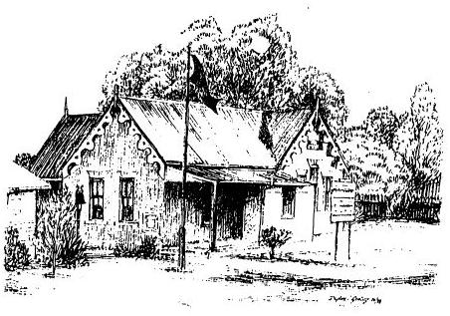
 | Fax: 48451236

1st December 2009

EXCURSION NOTE
Lilac City Cinemas
Tuesday 15th December 2009

Dear Parents and Caregivers

As our end of year treat, years K-6 will be going to the cinemas to see ‘Where the Wild Things Are’ – an adaptation of the famous children’s book. The movie session is at 12:00 and we will be leaving school at 11:10. Return trip at 1:30 to arrive at school by 2:15, allowing for traffic. There are no planned stops enroute.

Travel is by bus. There is no cost involved as drought assistance funds will support our end of year treat. Children should be in full sports uniform. We will eat lunch before we go and have party food (chips and lollies) on our return.

The teachers accompanying the children are Mrs Runnacles, Miss Belgrove and Mrs Doyle. Teachers have emergency care qualifications.

Please fill in the return slip so your children may attend:

---------------------------------------------------------------------------------------------------------------------

I give/ do not give (circle one) permission for my child / children:

________________________________________________________________________

to attend the Lilac City Cinemas in Goulburn on Tuesday 15th December 2009. I understand travel is by bus.

My child has the following special or medical needs:

__________________________________________________________________

Signature _______________________________________ Date _____________

